Sabrina M. Roblin, CPCC
VP Administration / Chief Learning Officer
Coaches Training Institute
4000 Civic Center Drive, Suite 500, San Rafael, CA 94903

Object : Application for CTI Front of the Room Leader (FORL)

Dear Sabrina,

In service of men and women in businesses as a partner in an accounting firm for over 9 years, I took an important turn in 2009, leaving behind my financial and professional security to follow my passion for human development. I first worked on myself. I took my training with CTI and I am now a certified professional coach with over 2,000 hours of individual and group coaching and leadership training. In addition, I participated in two of the most prestigious leadership programs in the world. One with CTI in California that led me to give conferences and to build a classroom in a school in Tanzania and one in France that led me to help them start their own leadership program in Quebec.

In 2009, I started my own business called Daniel Renaud Leadership. My job is to help companies and their leaders to take awareness and gain clarity on the future they want to build. I love working with entrepreneurs and executives because the development of their own leadership has a direct and strong impact on all the teams they lead.

I have a unique background and I lived with a thirst to make this world better one person at a time. If you are looking for someone passionate who will put all his heart in his work, it is with humility that I look forward to talk or to meet you to show you my interest in becoming a leader front of the room with CTI to serve in the development of co-activity.

I offer you, Sabrina, my warmest greetings.


Daniel Renaud PCC, CPCC, CPA, CA

Daniel Renaud PCC, CPCC, CPA, CA
4-620, Grande Allee Ouest
Quebec (Quebec) G1S 1B8

House & Office: (418) 661-9616 | Cell phone: (418) 655-4411

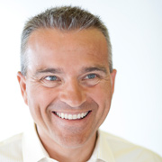 Email: daniel@danielrenaud.net
Web: www.danielrenaud.net

CERTIFICATION & TRAINING International Coach Federation member (ICF)
- THE BIGGER GAME with Rick Tamlyn, Montreal, Canada, 2013
- ARC - emergessence of the coach-leader, le playground, Paris, France, 2011-2012
- PCC accreditation (over 1000 hours of coaching), 2010
- CPCC, Coaches Training Institute, California, 2007
- Graduated from the «Co-Active Leadership program», http://www.thecoaches.com/leadership/ California, 2007
- Certification for assessment with The Leadership Circle, 2008
- Certification from Maieutik Canada for «individual motivation profiles», 2010

Member of the Chartered Professional Accountants of Quebec, Canada (CPA)
- Professional Chartered Accountant (CPA), 1999
- License in Accounting Science, Laval University, 1997
- Business administration degree, Laval University, 1986-1989

WORKING EXPERIENCE

2009-2013 Leadership coach & facilitator

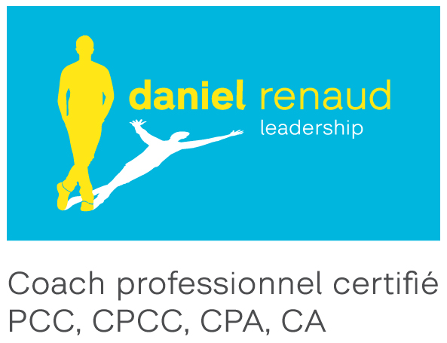
(www.danielrenaud.net)

- Executive and business coaching (clients on one-on-one basis);
- Organizational brokerage coach for CTI (Unicef);
- Personal positioning and transition coaching;
- Strategic planning (5 to 10 per year) with Small and Medium Companies;
- Leadership training facilitation in Africa and Quebec;
- Team building & relationship coaching for business partners.
It is through my role as a coach that I discovered my passion. I help men and women who want to develop their leadership to achieve great things. As a business coach, I approach the real thing, honestly and without judgment. I rise today as a professional co-active coach, trainer and facilitator for the development of leaders in both America and Africa.

2000-2009 Partner in a Chartered Professional Accountants firm
Renaud & Associé, CA and from 2002 under the name Malenfant Dallaire

The firm, with nearly fifty (50) employees, provides certification of annual financial statements and taxation service. My clientele consisted of over 100 SME clients in varied fields such as contractors (construction, aviation, etc.), industries (footwear manufacturing, printing, etc.), retailers, childcare and municipalities as well as Aboriginal and Para-governmental organizations.

In 2008, at the moment of my personal career repositioning, I served a clientele of more than 900 000 $ per year.

My main duties were:
- Act as Director of Human Resources;
- Represent and promote the firm during academic activities for recruiting new students;
- Manage teams working on certification mandates;
- Conduct the review of certification mandates, completion of annual financial statements and tax returns;
- Manage the relationship and meetings with clients;
- Support entrepreneurs & leaders to help them achieve their personal and professional heights.

  - Auditor accountant

Ernst & Young s.r.l. And Jean-Marc Renaud CA

1992-1993 Management consultant in a local cooperative banking organization in Yako, Burkina Faso, Africa (2 years)
Centre d’Étude et de Coopération Internationale (CECI)

- Develop strategies for the Union’s development;
- Participate in monitoring the management and accounting system;
- Prepare a compilation of statistical data and a study for each Cooperative;
- Lead and train officers in promoting work organization.

OTHER ACCOMPLISHMENTS

- Just published my first book «Vivre dans un cadre de porte…jusqu’à quand ?» on making conscious choices co-written with a coaching client. It was published by Les Éditions Québécor in September 2012 (I did participate to the Int’l bookfair of Montréal in October 2012 and in Quebec City in April 2013)



http://www.amazon.ca/Vivre-cadre-porte-jusquà-quand/dp/2764017278/ref=sr_1_1?ie=UTF8&qid=1372214953&sr=8-1&keywords=vivre+dans+un+cadre+de+porte

- Treasurer & Board member for ICF Quebec, 2011-2013

- Mission with business leaders in Burkina Faso (2 weeks - 2010) and volunteer with the CFCI in Mali, Africa (3 months - 1991)

- Cofounder of «One Global Action» project to raise funds for the construction of a classroom at school Kambi Ya Nyoka in Karatu, Tanzania (2008)

- Co-owner B&B «Le Tour de L’Île» on Orleans Island, Qc (1994-1997)

- Training in photography and freelance photography contracts for 3D Vision International, Montreal (1995)

- Crossing the Atlantic Ocean on a sailboat on the "Chantauvent" (1993)

PASSIONS
- Traveling and Photography
- Running (marathon in 2008 and numerous half-marathons)
- The adventure of the human experience because my passion is connection.

- My family (my wife Jocelyne for 23 years now and we have 3 children (Gabriel 21, Claudelle 18 and Clemence 17)

PERSONAL VALUES
- Freedom
- Discovery & Adventure
- Accomplishment
- Authentic relationship
- Simplicity

